# CRM Application for Jewel Management- (Developer)

College Name: BHARATHIDASAN COLLEGE OF ARTS AND SCIENCE

College Code:

bru3d

TEAM ID:

NM2025TMID24688

TEAM MEMBERS:



**Team Leader Name:**

Chandru.K

**Email:**

[ck6582293@gmail.com](mailto:ck6582293@gmail.com)

**Team Member 1:**Jayaram.G

**Email:**[dondonjeeva739@gmail.com](mailto:dondonjeeva739@gmail.com)

**Team Member 2:**Pritheev.U

**Email:**[upritheev@gmail.com](mailto:upritheev@gmail.com)

**Team Member 3:** Murugan.V

**Email:**

[Abishek25100@gmail.com](mailto:Abishek25100@gmail.com)

# 1.INTRODUCTION

## 1.1 Project Overview

The Jewel Inventory System is a comprehensive software solution developed to simplify and automate the inventory and sales management processes for jewellery stores and manufacturers. It enables businesses to efficiently track a wide range of jewellery items, maintain accurate stock records, and manage day-to-day operations with ease.

The systemis designed to improve accuracy,reduce manual effort , and provide better visibility into inventory and sales data.

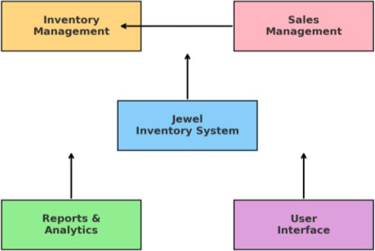

## 1.2 Purpose

The purpose of the Jewel Inventory System is to provide an efficient and user-friendly platform that streamlines inventory management and stock tracking, ensures accurate record-keeping of jewellery Items, facilitates seamless and reliable sales transactions, and enhances overall operational efficiency for jewellery businesses.

# DEVELOPMENT PHASE

Creating Developer Account:

By using this URL-[https](https://www.salesforce.com/form/developer-signup/?d=pb)://[www](https://www.salesforce.com/form/developer-signup/?d=pb).[salesforce](https://www.salesforce.com/form/developer-signup/?d=pb).[com](https://www.salesforce.com/form/developer-signup/?d=pb)/[form](https://www.salesforce.com/form/developer-signup/?d=pb)/[developer](https://www.salesforce.com/form/developer-signup/?d=pb)-[signup](https://www.salesforce.com/form/developer-signup/?d=pb)/?[d](https://www.salesforce.com/form/developer-signup/?d=pb)=[pb](https://www.salesforce.com/form/developer-signup/?d=pb)



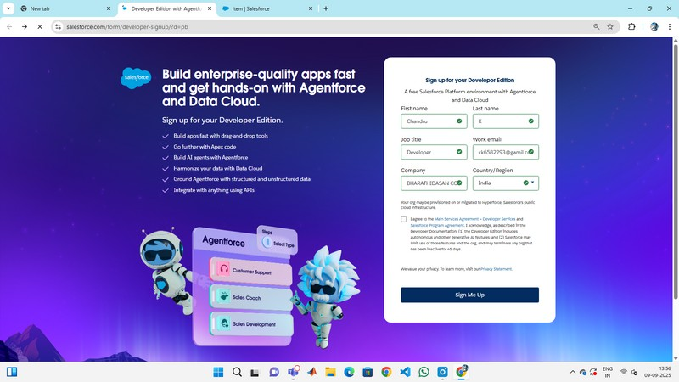

* + - Created objects: Jewel Customers , Items , Customer Order , Price , Billing

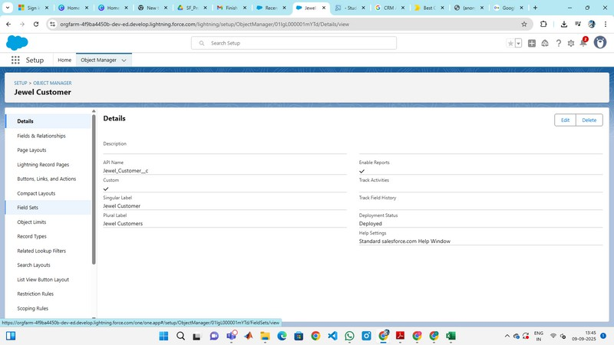

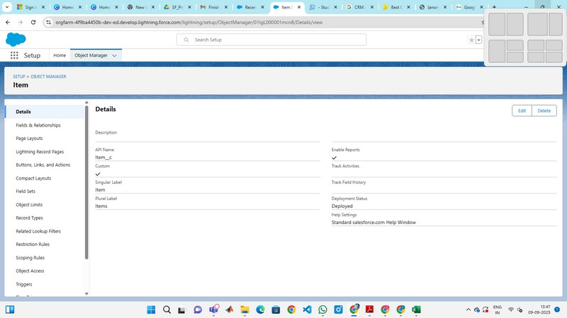

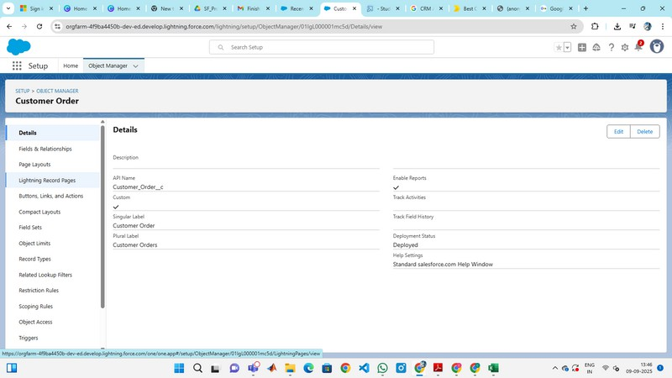

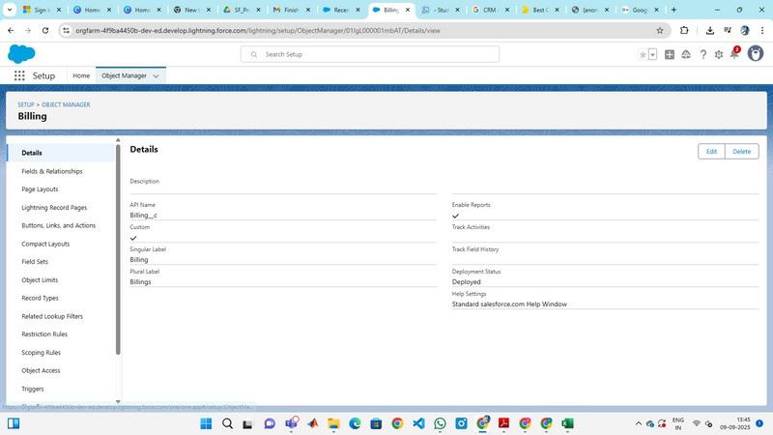



* + - * Creating a tabs

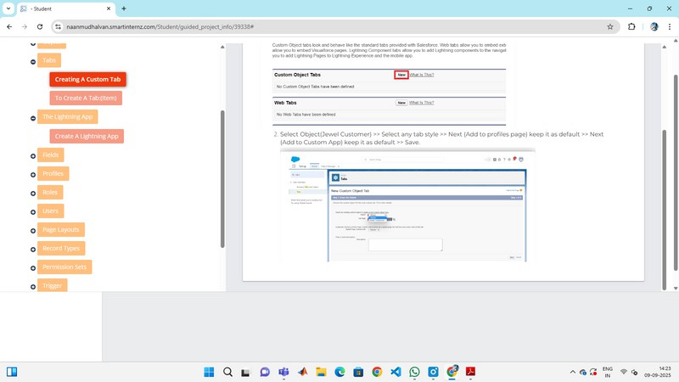

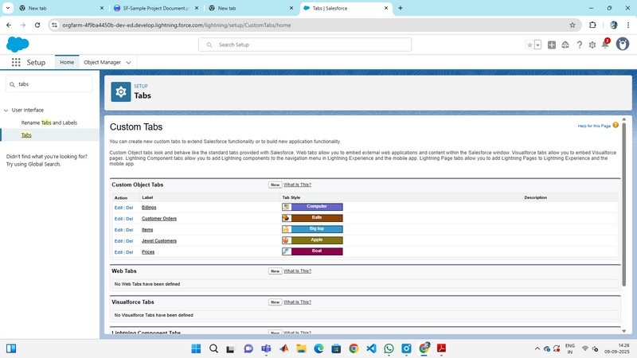

* + - * Configured fields and relationships

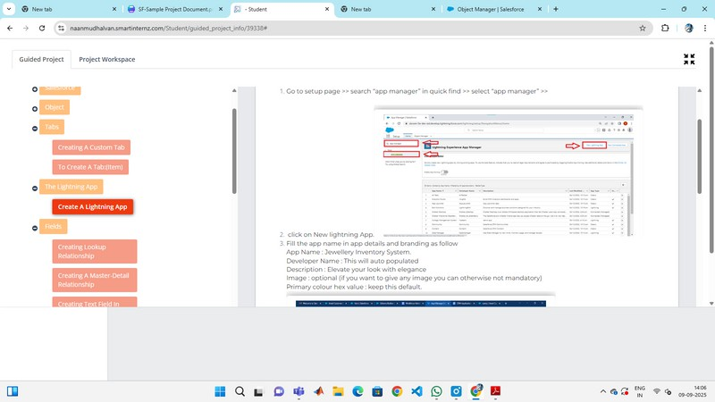

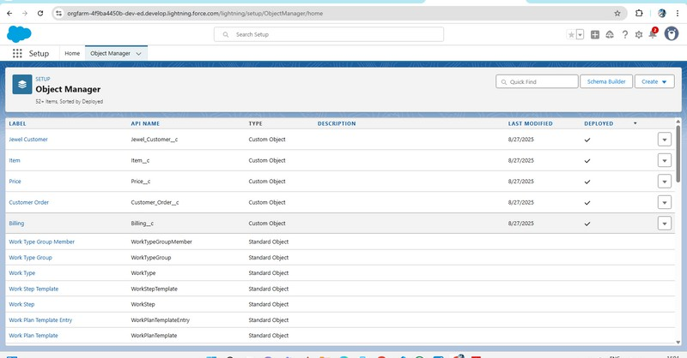

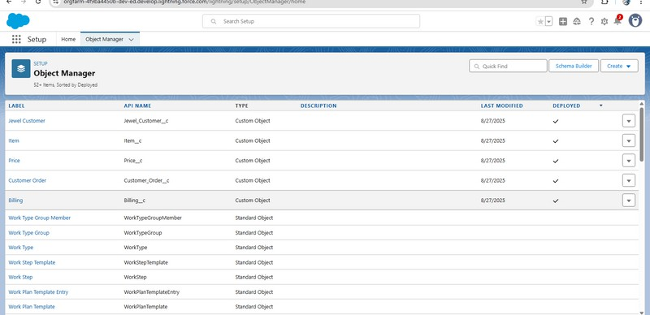

* + - * Developed Lightning App with relevant tabs

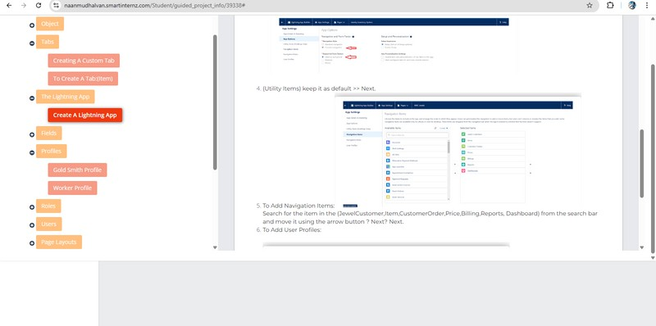

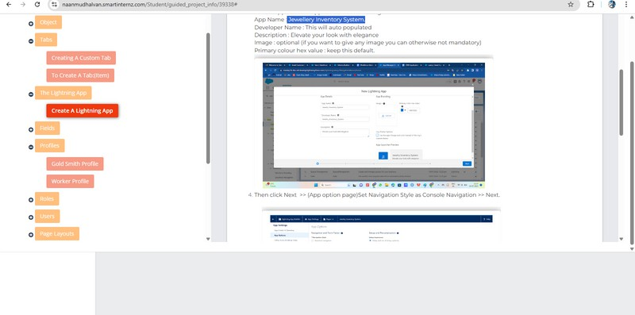

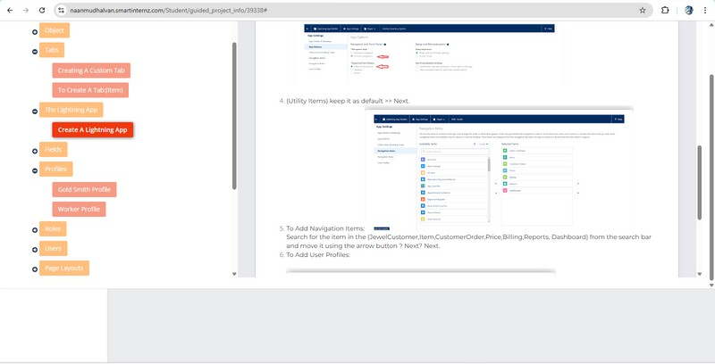

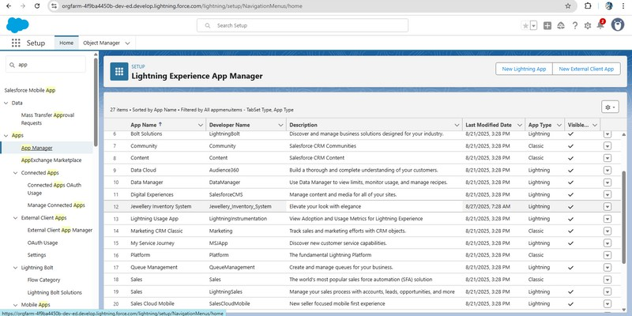

* Additional fields and relationships

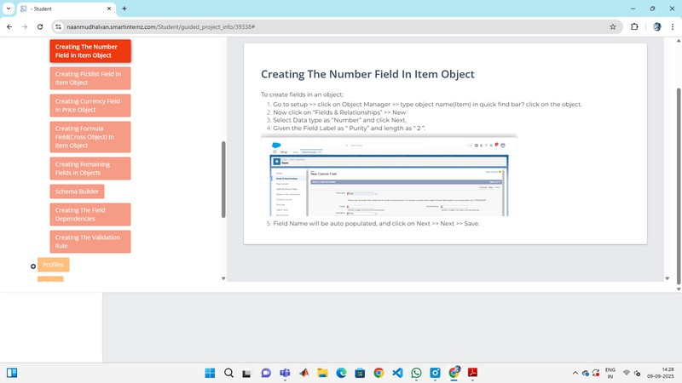

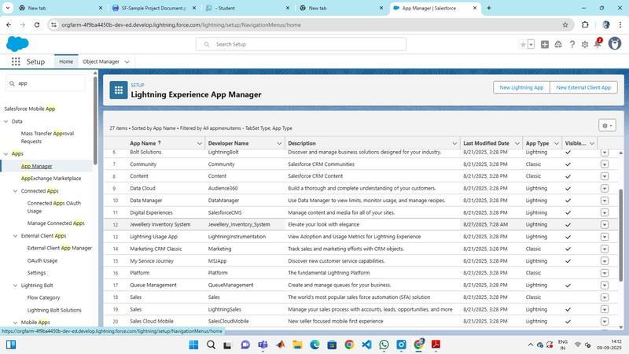

* Flows to check billing

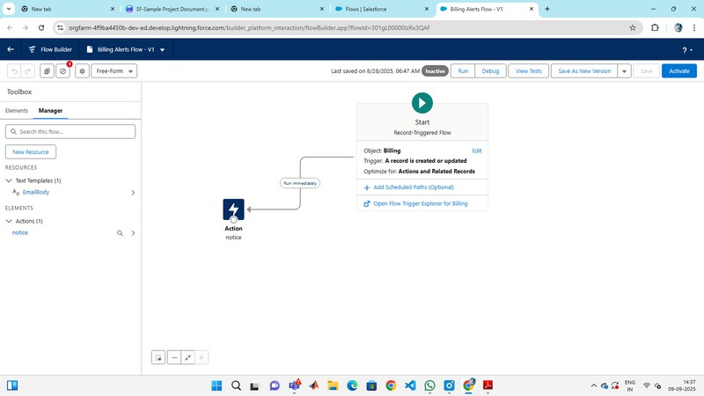

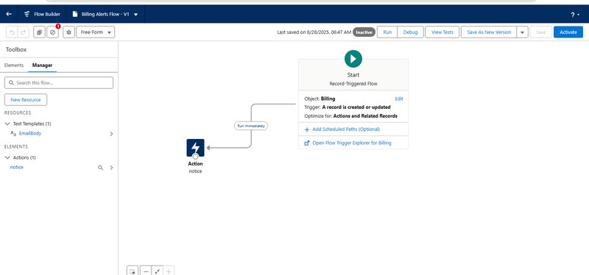



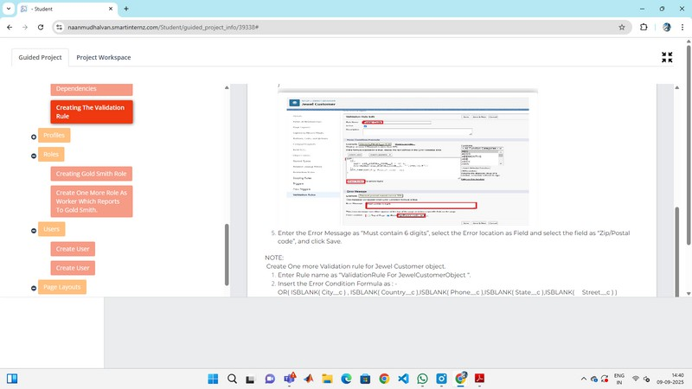

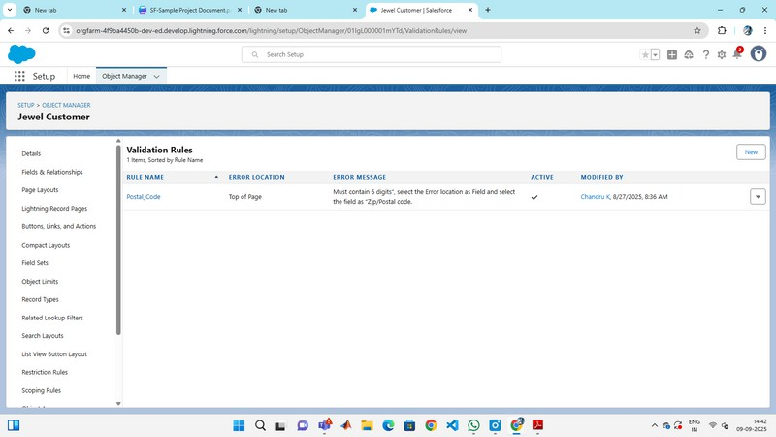

* + Apex Trigger

Createan Apex Trigger

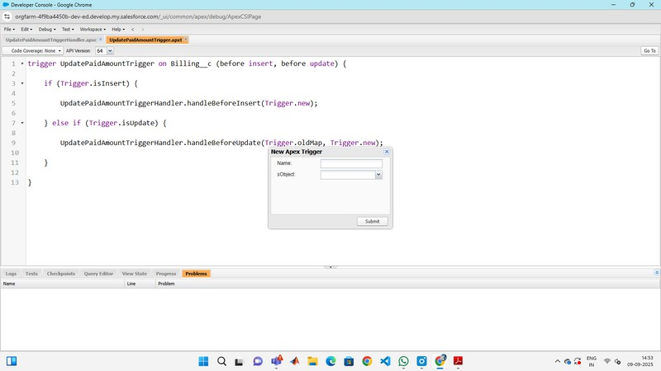

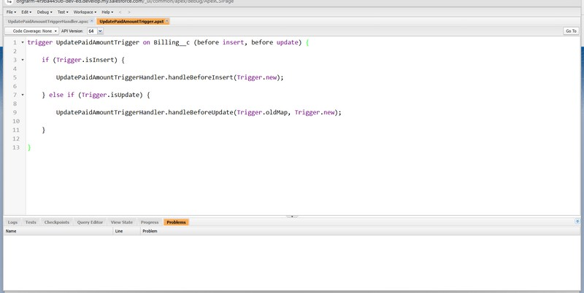

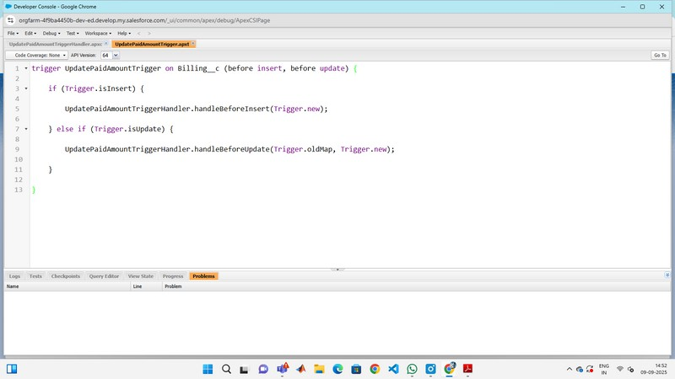

Createan Apex Handler class

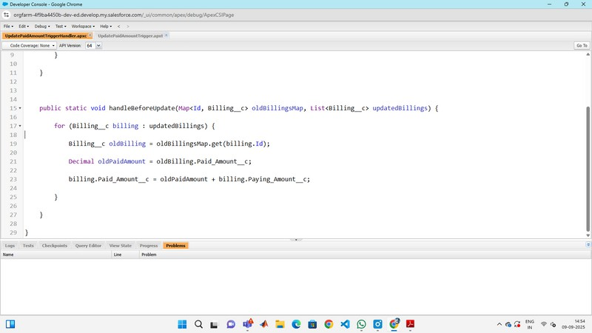

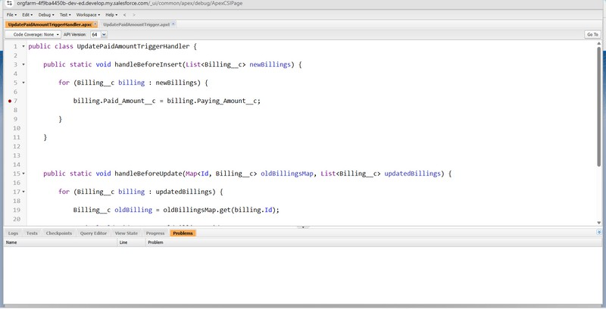

* + FLOWS

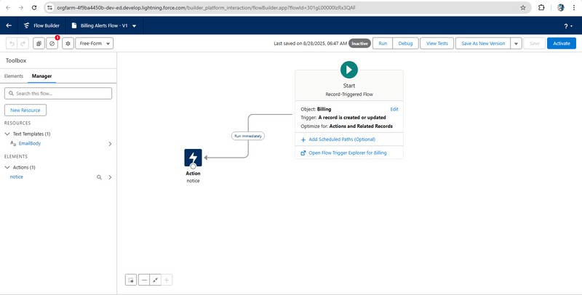

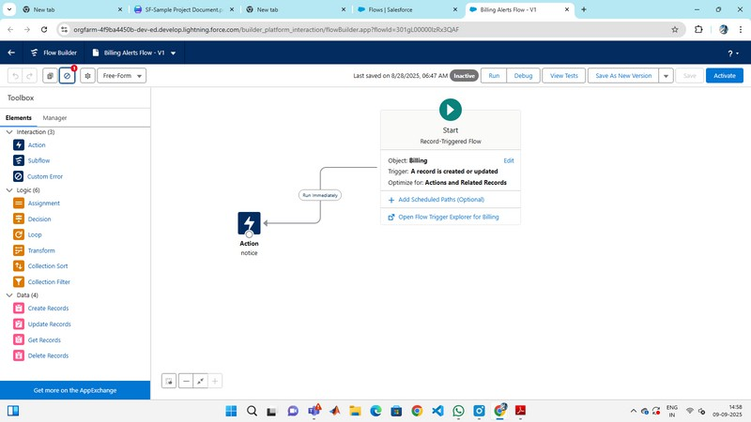

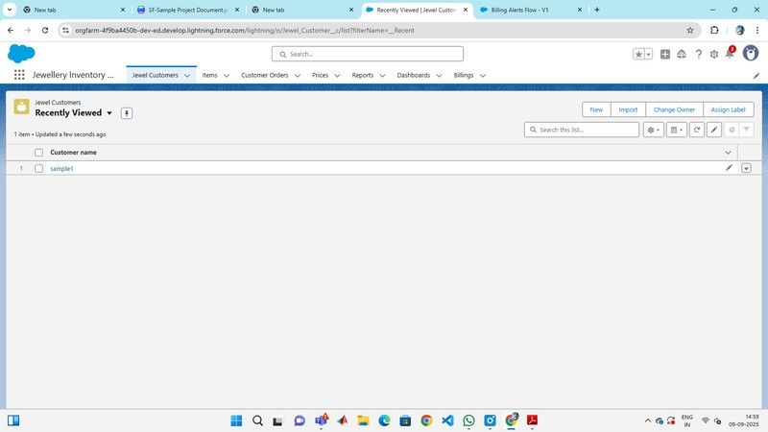

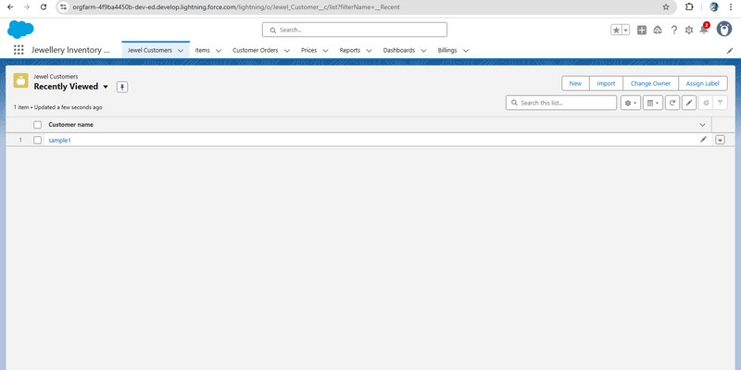

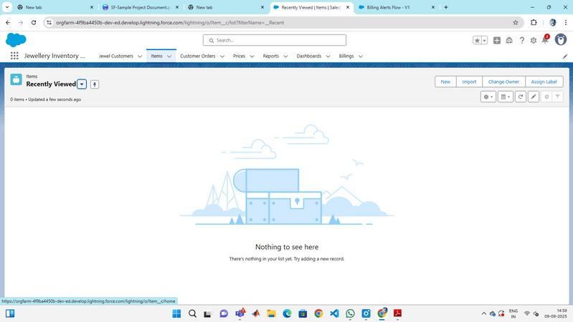

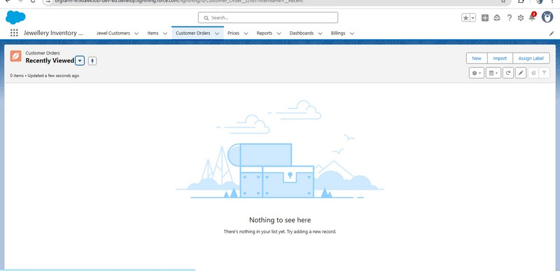

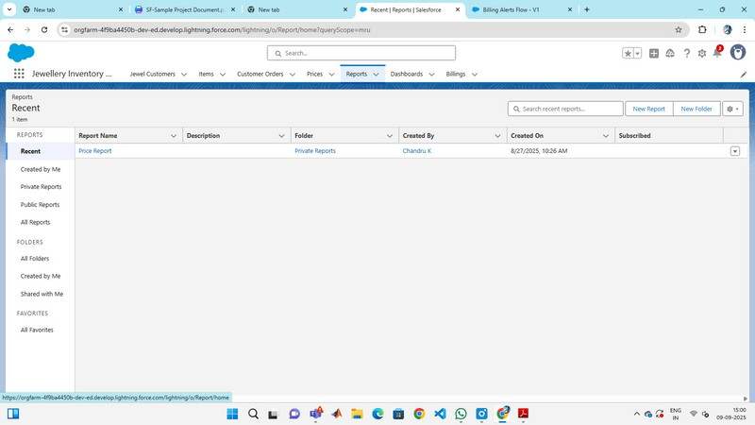

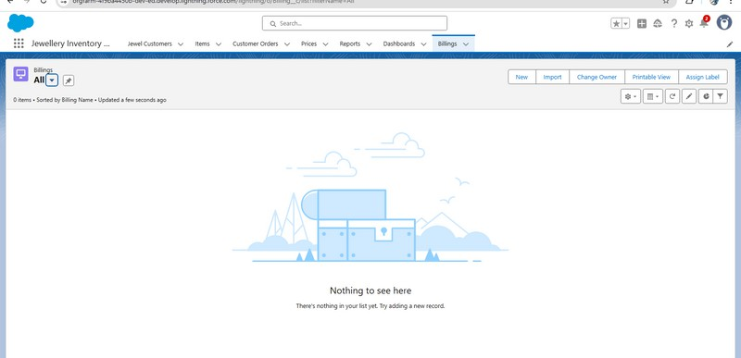



# FUNCTIONAL AND PERFORMANCE TESTING

## PerformanceTesting

* Addinganewcustomer

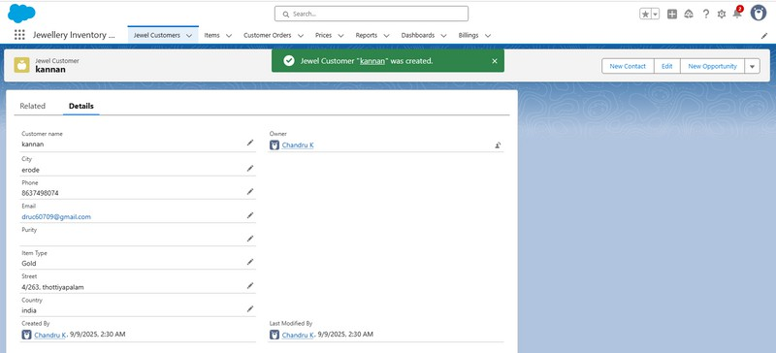

* Validation Rule checking in a customer

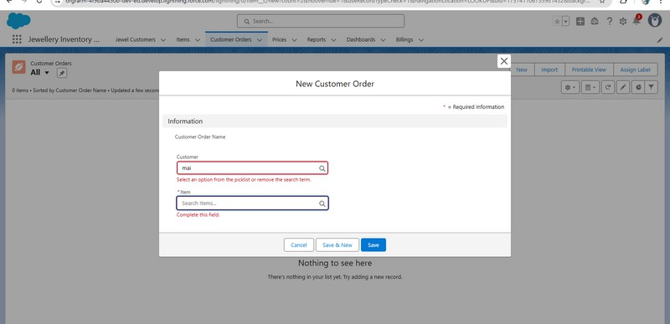

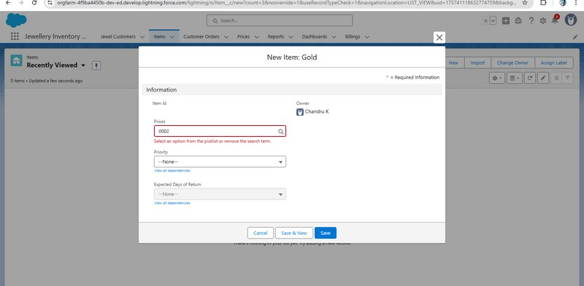

* Flows on billing

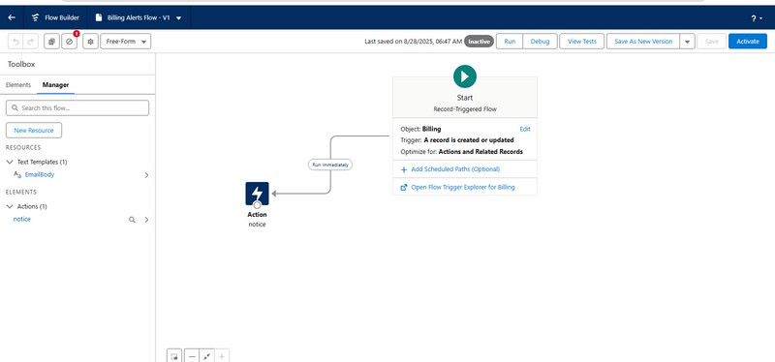

* Approval process validated through customer name and details

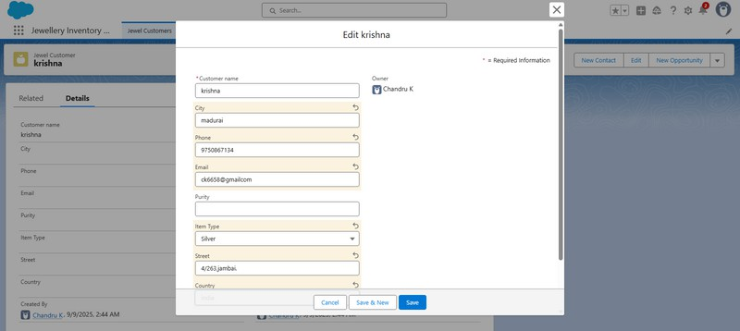

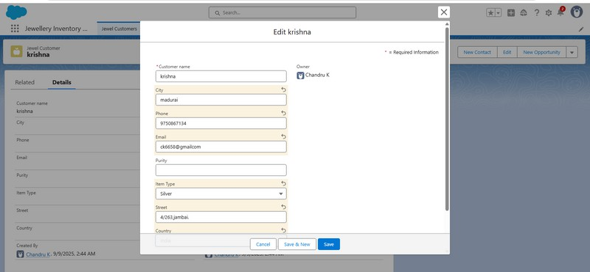

# RESULTS

## Output Screenshots

* + Tabs for Property :billing,prices,customer,items , jewel customer

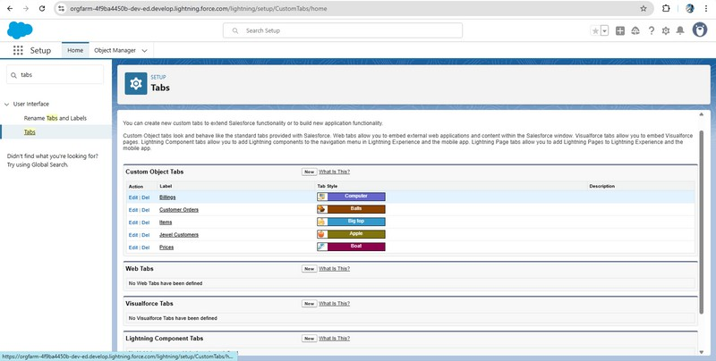

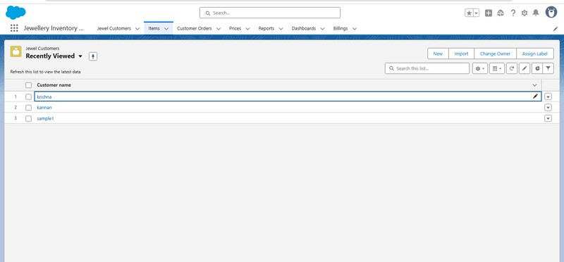

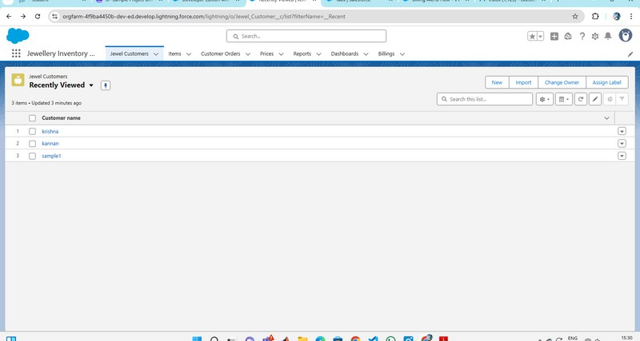

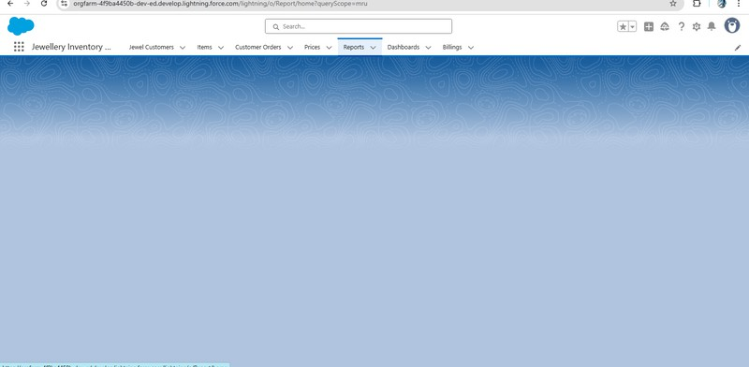

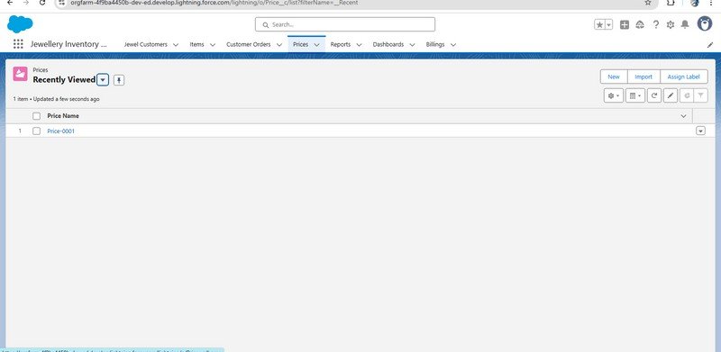

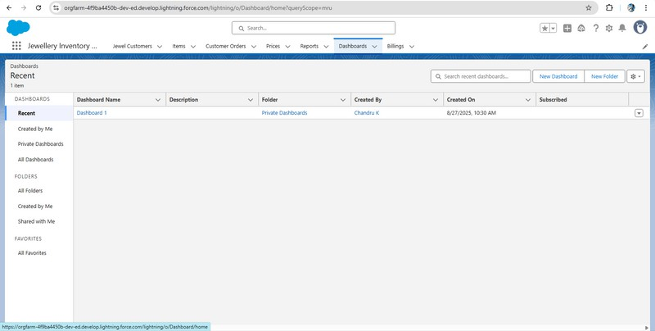

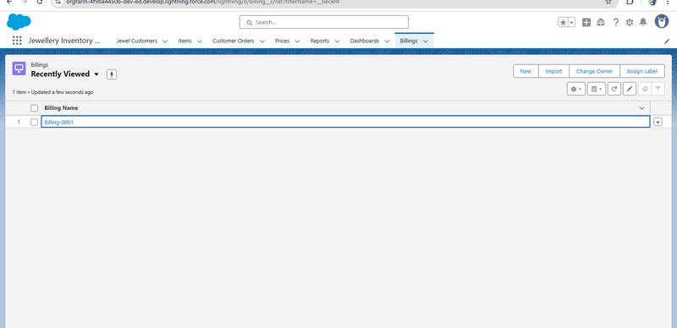

* + Flows runs

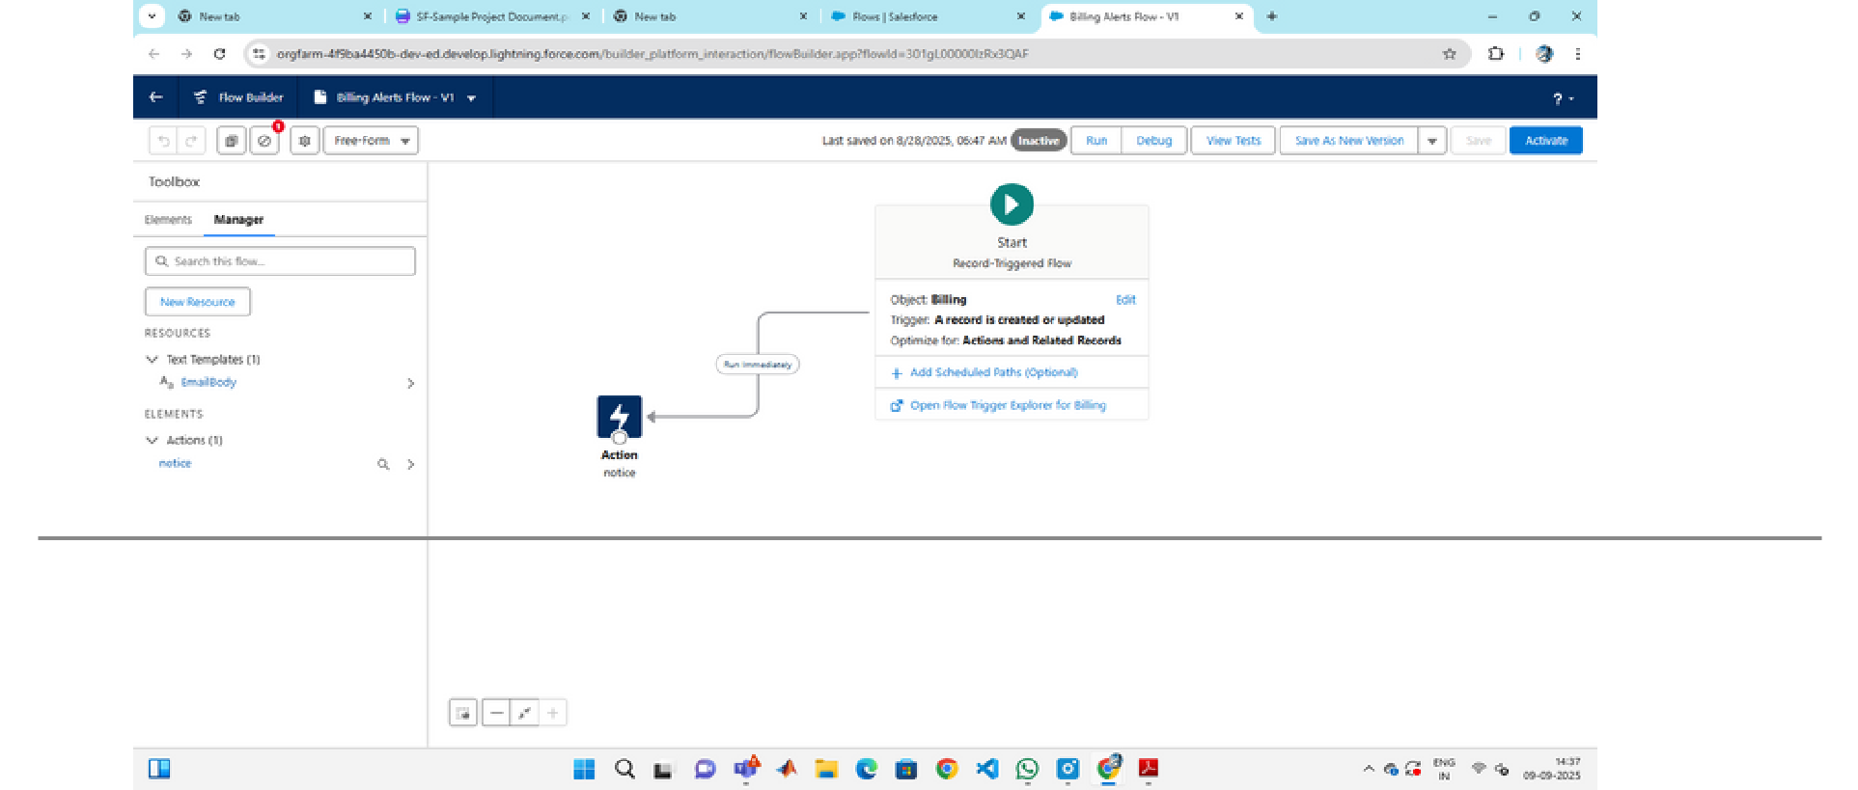

# ADVANTAGES & DISADVANTAGES



## **Advantages:**

Improves inventory accuracy, streamlines sales, and reduces manual effort with an easy-to-use system.

## **Disadvantages:**

Requires initial setup cost, technical knowledge, and ongoing system maintenance.

CONCLUSION

The Jewel Inventory System serves as an efficient and reliable solution for jewellery businesses by streamlining inventory and sales management. It reduces manual errors, saves time, and enhances operational efficiency while providing accurate insights into stock and transactions. This ultimately helps businesses improve productivity, ensure customer satisfaction, and achieve sustainable growth.



## APPENDIX

* + Source Code: Provided in Apex Classesand Triggers

public class UpdatePaidAmountTriggerHandler

{

public static void handleBeforeInsert(List<Billing__c> newBillings)

{

for (Billing__c billing : newBillings)

{

billing.Paid_Amount__c = billing.Paying_Amount__c;

}

}

}

Public static void handle Before Update(Map<Id,Billing__c>old Billings Map, List<Billing__c>updatedBillings){

for(Billing__cbilling:updatedBillings){

Billing__coldBilling=oldBillingsMap.get(billing.Id);

DecimaloldPaidAmount=oldBilling.Paid_Amount__c;

billing.Paid_Amount__c=oldPaidAmount+billing.Paying_Amount__c;

}

}

}

Update Paid Amount Trigger

### triggerUpdatePaidAmountTriggeronBilling__c

(beforeinsert,beforeupdate){

if(Trigger.isInsert){

### Update Paid Amount Trigger Handler.handle Before Insert(Trigger.new);

}elseif(Trigger.isUpdate){

### Update Paid Amount Trigger Handler.handle Before Update(Trigger.oldMap,Trigger.new);

}

}